Look at This Good Cross-Country Aircraft! It Is Roomy and Comfortable
Only 196 Hours Since Major Overhaul and Air Conditioning!

STATUS
- TOTAL TIME, AIRFRAME: 1,351 HOURS
- ENGINE: 196 HOURS
- PROPELLER: 196 HOURS
- ANNUAL: MAY 2019
- USEFUL LOAD: 975 POUNDS
- NO DAMAGE HISTORY

EXTERIOR/INTERIOR
- EXTERIOR TRIM: MATTERHORN WHITE OVER, GREEN METALLIC WITH TITANIUM TRIM
- INTERIOR: FULL GENUINE SILVERSTONE GRAY LEATHER SEATS AND SIDE PANELS
- GRAY AND BLACK CARPET

AVIONICS
- GARMIN GNS530 WASS GPS/IFR MOVING MAP DISPLAY/NAV COM
- GARMIN GNS430 GPS/IFR MOVING MAP DISPLAY/NAV COM
- GARMIN GI106 GLIDESLOPE INDICATOR, COUPLED TO GNS430
- GTX 345 TRANSPONDER WITH ENCODER, ADS-B COMPLIANT
- PS ENGRG. PMA7000M AUDIO PANEL/MKB/4 PL. STEREO INTERCOM SYSTEM; INCLUDING
- PS ENGRG. PCD7100 STEREO CD PLAYER
- EDM800 ENGINE ANALYZER/FUEL FLOW TOTALIZER
- KING KCS55A HSI
- BF GOODRICH WX500 WEATHER MAPPING SENSOR (SHOWS WEATHER ON GPS MAPS)
- AVIDYNE TCAD SYSTEM WITH VOICE CALL OUT WARNINGS (SHOWS TRAFFIC ON GPS MAPS)

AUTOPILOT
- KING KFC225 A/P-F/D WITH YAW DAMPER AND ALT PRESELECT AND AP DISCONNECT

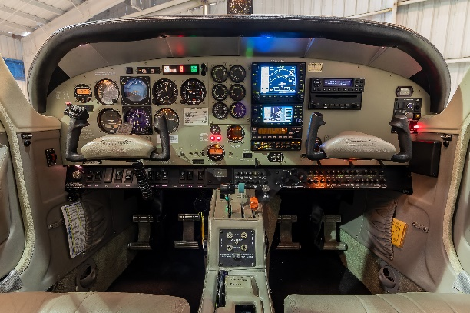
ADDITIONAL EQUIPMENT
- DUAL PTT
- HOBBS METER
- DUAL ALTERNATORS
- BACKUP VACUUM DG
- MAIN TAXI LIGHTS (LED)
- VORTEX GENERATORS
- DUAL VACUUM SYSTEM
- 88 GAL. FUEL CAPACITY
- PNEUMATIC DOOR STAYS
- AUTOMATIC ELECTRIC TRIM
- ALTERNATE STATIC SOURCE
- FACTORY AIR CONDITIONING
- WING LEADING EDGE LIGHTS
- FACTORY 4 PL. 77 CU. FT. OXYGEN SYSTEM
- PRECISE FLIGHT PULSE LIGHT SYSTEM (LED)

