Air conditioned, ADS-B in and out, G1000 WAAS equipped, SVT

STATUS
- Total time, airframe: 1,716 hours (times are subject to change)
- Left Engine: 859 hours SNEW
- Right Engine: 0 hours SMOH
- Left Propeller: 28 SPOH in May 2020
- Right Propeller: 28 SPOH in May 2020
- Annual: May 2020
- Useful load: 951 lbs.

EXTERIOR/INTERIOR
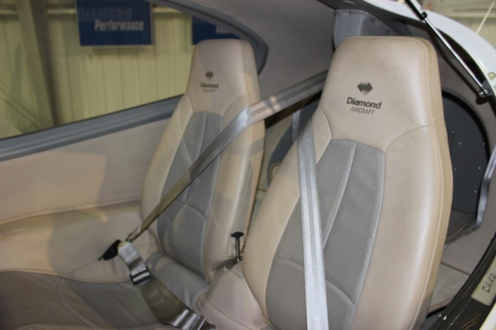
- White with Blue, Silver and Burgundy accents
- Premier tan and grey leather upholstery
- Leather interior upgraded 2011
- Canopy upgrade 2011

AVIONICS
- Garmin G1000 - GDU1040, 10-inch primary flight display and
multi-function display
- G-1000 with synthetic vision with WAAS
- Garmin integrated VFR terrain awareness system
- Remote avionics mounting rack with line replaceable units
- GEA71 airframe/engine interface unit
- Dual Garmin GIA 63W COM/NAV/GPS
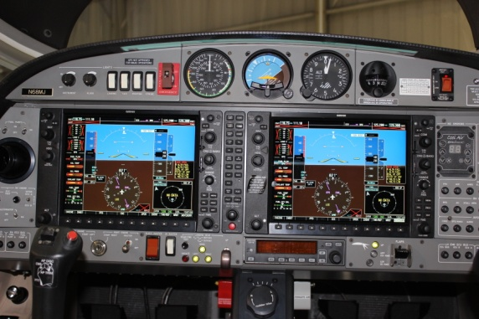
- GMA1347 digital audio system
- GTX 345R Transponder ADS-B in/out
- GRS77 solid-state attitude heading reference system
- GDC74 digital air data computer
- GMU44 magnetometer
- GDL69A XM satellite weather and radio – Subscription required
- ELT ARTEX 406 MHz

AUTOPILOT
- Honeywell KAP140 Dual Axis autopilot - altitude hold/ preselect
- Standby instruments (compass, horizon, air speed indicator, altimeter)

ADDITIONAL EQUIPMENT
- Cool Air, air conditioning installed 2015
- Austro 300 Diesel Engines
- Auxiliary fuel tanks
- New wing walks

