BEST EQUIPPED SENECA AVAILABLE • WITH FRESHLY OVERHAULED ENGINES AND PROPELLERS • ADS-B IN/OUT • ASPEN PFD • YOU HAVE TO SEE IT!

STATUS
- TOTAL TIME, AIRFRAME: 1,850 HOURS
- ENGINES: 28 HOURS SINCE MAJOR OVERHAUL
- PROPELLERS: 28 HOURS SINCE MAJOR OVERHAUL
- ANNUAL: APRIL 2019 BY PREMIER AIRCRAFT SERVICE
- NO KNOWN DAMAGE HISTORY

EXTERIOR/INTERIOR
- EXTERIOR TRIM: TAN AND GREEN
- INTERIOR: LIGHT TAN LEATHER
- EXECUTIVE WRITING TABLE

AVIONICS
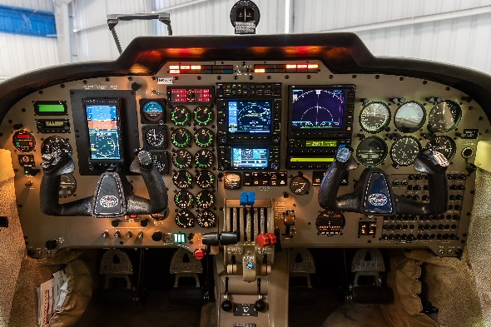
- GARMIN 530 WAAS
- GARMIN 430 WAAS
- GARMIN GMA 340 AUDIO PANEL
- GARMIN GTX345 TRANSPONDER – ADS-B IN AND OUT
- APOLLO MX20 MFD WITH CHARTVIEW AND TERRAIN
- RDR 2000 VERTICAL PROFILE RADAR WITH MX20 MFD DISPLAY
- SATELLITE DATALINK WEATHER
- PILOT STANDBY ELECTRIC ATTITUDE INDICATOR
- PILOT BACKUP AIRSPEED INDICATOR
- PILOT BACKUP ALTIMETER
- PILOT BACKUP TURN COORDINATOR
- ASPEN EVOLUTION PFD
- WX500 STORMSCOPE – DISPLAYS ON 530/430/MX20
- 497 SKYWATCH TRAFFIC SYSTEM – DISPLAYS ON 530/430/MX20
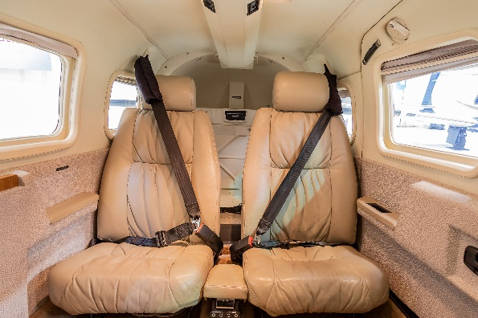
- EDM 760 ENGINE MONITOR
- BOSE HEADSET CONNECTORS

AUTOPILOT
- S-TEC 55X AUTOPILOT WITH ST-360 ALT PRESELECTOR WITH YAW DAMPNER

ADDITIONAL EQUIPMENT
- FULL DEICING SYSTEM
- FACTORY AIR CONDITIONING
- FULL COPILOT INSTRUMENTS
- PROPELLER SYNCHROPHASER
- FACTORY 6 PLACE OXYGEN SYSTEM

