Active Traffic (TAS)
2005 Cessna 182T Skylane with G1000
N696EA Ser#18281722

418 Total Time Since New

Avionics:
GMA-1347 Digital Audio Panel with Marker Beacon/Intercom
CI-102 Marker Beacon Antenna
GTX-33 Transponder - Mode S with TIS
CI-105 Transponder Antenna
GIA-63 NAV/COM/GPS with Glideslope #1
GIA-63 NAV/COM/GPS with Glideslope #2
CI-2480 VHF/GPS Antenna with Internal Notch Filter #1
CI-2480 VHF/GPS Antenna with Internal Notch Filter #2
CI-120 NAV Antenna
GDU-1040 Primary Flight Display (PFD)
GDU-1040 Multi-function Display (MFD)
GEA-71 Engine/Airframe Computer
• CHT/EGT Sensors - All Cylinders
• Fuel Flow Meter
• Manifold/Tachometer/Vacuum Sensors
GRS-77 AHRS
GDC-74 Air Data Computer with OAT Probe
GMU-44 Magnetometer
KAP-140 Dual Axis Autopilot with Altitude Preselect/GPS Roll Steering
KCM-100 Configuration Module
KS-270C Pitch Axis Servo Actuator
KS-271C Roll Axis Servo Actuator
KS-272C Pitch Trim Servo Actuator
Pilot Control Wheel - Pitch Trim Switch / Autopilot Disconnect
Artex ME406 Emergency Locator Transmitter
Emergency Locator Transmitter External Antenna
Emergency Locator Transmitter Remote Mounted Switch
WX-500 Stormscope
NY-163 Stormscope Antenna
Control Wheel Push-To-Talk Switch - Pilot/Copilot
Mic & Phone Jacks - Pilot/Copilot/Passengers
Auxiliary Stereo Input Jack
Deck Skin Cooling Fan #1 - Instrument Panel
Avionics Cooling Fan #2 - PFD
Avionics Cooling Fan #3 - MFD
Aft Avionics Cooling Fan #4 - Avionics Equipment
LED Lighted Switch Panel
LED Light Circuit Breaker Panel
Blind Turn Coordinator for KAP-140 Roll Rate Data
Backup Single Pump Vacuum System - Dry
Standby Battery Controller
Standby Battery, 24 volt 6.2 AH
Backup Attitude Gyro, Airspeed & Altimeter Indicator
GDL-69A XM Satellite Data / Radio Receiver
AmSafe Inflatable Seat Belts & Shoulder Harness STC, Inertia Reel, Pilot/Co-Pilot

Additional Equipment:
Active Traffic (TAS)

Exterior:
Matterhorn White with Arista Blue and Diamond Silver Painted Stripes

Interior:
Leather Seat Surfaces, Mink Leather with Perforated Mink Leather Insert / Mink Vinyl

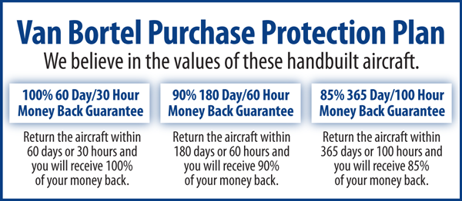

We fly the aircraft to your ramp for inspection by you and your mechanic at no cost or obligation to you.

All Specifications Subject To Verification Upon Inspection

Trades Welcome • No Damage History • Always Hangered • No Corrosion

