FAST, STYLISH AND COMFORTABLE…THAT’S THE TTX! GARMIN G2000 WIDESCREEN GLASS PANEL TOUCHSCREEN CONTROL • SUPERBLY MAINTAINED • AIR-CONDITIONED
WAAS • SVT, TAWS-B • ADS-B OUT!

STATUS
- TOTAL TIME, AIRFRAME: 769 HOURS SINCE NEW
- ENGINE: 769 HOURS SINCE NEW
- TELEDYNE CONTINENTAL PLATINUM TSIO-550-C
- PROP: 769 HOURS SINCE NEW
- HARTZELL 3-BLADE CONSTANT SPEED HOT PROP
- FRESH ANNUAL INSPECTION
- NO DAMAGE HISTORY

EXTERIOR/INTERIOR
- WHITE OVER GREY WITH BLACK TRIM STRIPES
- GREY LEATHER INTERIOR

AVIONICS
- GARMIN G2000 WIDESCREEN GLASS PANEL
- GMA-36 REMOTE DIGITAL AUDIO PANEL WITH MARKER BEACON/INTERCOM
- GTC-570 TOUCH SCREEN CONTROLLER
- GTX-33ES TRANSPONDER – MODE S, WITH TRAFFIC INFORMATION SYSTEM CAPABILITY – ADS-B OUT
- GIA-63W NAV/COM/GPS/WAAS WITH GS #1
- GIA-63W NAV/COM/GPS/WAAS WITH GS #2
- GDU-1400 PRIMARY FLIGHT DISPLAY (PFD)
- GDU-1400 MULTI-FUNCTION DISPLAY (MFD)
- GEA-71 ENGINE/AIRFRAME COMPUTER
- GRS-77 AHRS (DUAL)
- GDC-74A AIR DATA COMPUTER WITH OAT PROBE
- GMU-44 MAGNETOMETER (DUAL)
- GDL-69A FLIGHT INFORMATION SYSTEM (FIS) WITH XM RADIO
- GCU-275 PRIMARY FLIGHT DISPLAY (PFD) CONTROLLER
- TERRAIN AWARENESS SYSTEM (TAWS-B)
- ELECTRONIC CHECKLIST
- GTS-800 TRAFFIC ADVISORY SYSTEM
- ESI-1000 L-3 TRILOGY (BACKUP AIRSPEED, ALTIMETER AND ATTITUDE (ELECTRIC) INDICATOR)
- CONTROL STICK PUSH-TO-TALK SWITCH, PILOT AND COPILOT
- MIC AND PHONE JACKS-PILOT/COPILOT/PASSENGERS (BOSE AND STANDARD)
- GARMIN SAFETAXI AND FLITECHARTS (FLITECHARTS DO NOT PROVIDE GEOSYNCHRONOUS POSITIONING)
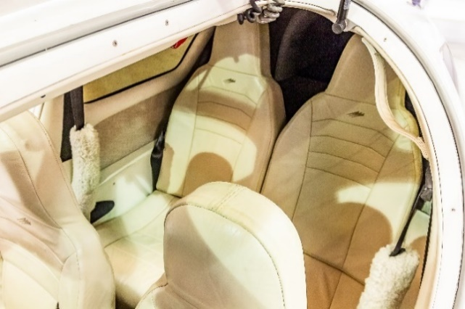
- ARTEX ELT-ME406 EMERGENCY LOCATOR TRANSMITTER
- PITOT SYSTEM – HEATED
- STATIC SYSTEM
- ALTERNATE STATIC SOURCE
- ELECTRONIC STABILITY PROTECTION (ESP)
- GARMIN 0534.16 SYSTEM SOFTWARE

AUTOPILOT
- GFC 700 AUTOPILOT
- GMC-720 AUTO FLIGHT CONTROLLER SYSTEM (AFCS)

ADDITIONAL EQUIPMENT
- RUDDER HOLD
- OREGON AERO HI-G SEATS
- PRECISE FLIGHT SPEED BRAKES
- GARMIN 0534.16 SYSTEM SOFTWARE
- PRECISE FLIGHT BUILT-IN OXYGEN SYSTEM
- MCCAULEY PROPELLER WITH ELECTRIC DE-ICE SYSTEM
- DIGITAL CLIMATE CONTROL AND ELECTRIC AIR CONDITIONING
- AMSAFE INFLATABLE RESTRAINTS FOR THE PILOT AND COPILOT SEATING POSITIONS

