Perfect for Island-Hopping or Multi-Engine Training!
150 KTAS At Only 9 GPH!
Like-New Aircraft with Only 160 Hours Total Time!

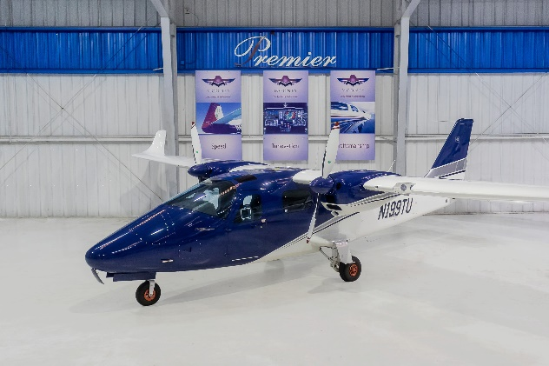
STATUS
- AIRFRAME, TOTAL TIME: 160 HOURS
- LEFT ENGINE: 160 HOURS
- RIGHT ENGINE: 160 HOURS
- LEFT PROPELLER: 160 HOURS
- RIGHT PROPELLER: 160 HOURS
- ANNUAL COMPLETED: MARCH 2019
- IFR CERTIFICATION COMPLETED: JUNE 2019

ENGINES
- ENGINES – 2 ROTAX 912S3 100 HP, 4 CYLINDERS
- LIQUID/AIR COOLED, INTEGRATED REDUCTION GEAR
- DUAL IGNITION SYSTEM
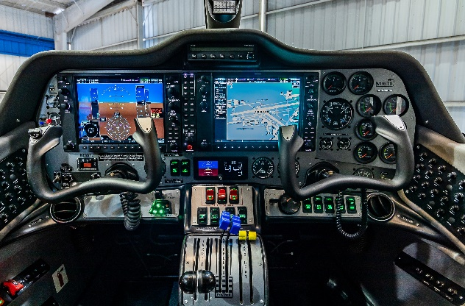
- THROTTLE CONTROL LH/RH
- TUBULAR STEEL ENGINE MOUNT

PROPELLERS
- 2 MT, 2 BLADES, CONSTANT SPEED, FULL FEATHERING

EXTERIOR/INTERIOR
- EXTERIOR: WHITE AND BLUE BASE COAT WITH SILVER AND BLACK ACCENT STRIPING
- EXTERIOR PAINT UPGRADE
- INTERIOR: DARK BLUE LEATHER INTERIOR
- LUXURY INTERIOR UPGRADE

AVIONICS
- GARMIN G950 AVIONICS PACKAGE
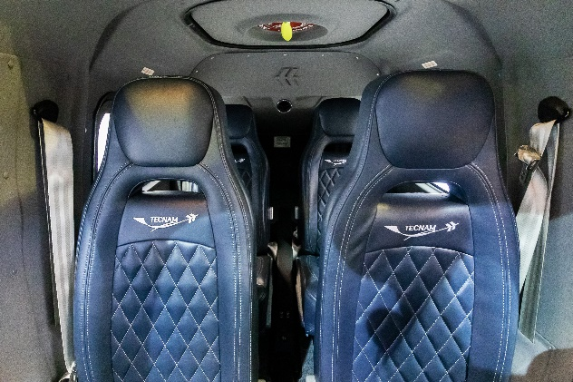
- DUAL GIA 63 WAAS COM/NAV/GPS
- GMA 1347 DIGITAL AUDIO SYSTEM
- GMU 44 MAGNETOMETER
- GDC 72 AIR DATA COMPUTER
- GRS 79 AHRS
- ANALOG ENGINE INSTRUMENTS
- MIDCONTINENT MD302 BACK-UP INSTRUMENT
- GARMIN GTX 345R MODE S TRANSPONDER ADS-B IN/OUT

AUTOPILOT
- STEC 55X AUTOPILOT

ADDITIONAL EQUIPMENT
- SURROUND VIEW WINDOWS
- BERINGER WHEELS AND BRAKES
- HEATED PITOT SYSTEM

