2006 DIAMOND DA42-TDI
N37vk – SN 42.AC056
Price: inquire – trades welcome!

ONE OF A KIND DA42! THE ONLY ONE AVAILABLE with radar/camera nose that is equipped AS AN mmp! YOU HAVE TO SEE IT!

STATUS
- AIRFRAME: 1,927 HOURS (SUBJECT TO CHANGE)
- ENGINES: 755 HOURS 2.0L
- PROPELLERS: 1,927 HOURS
- ANNUAL: APRIL 2018
- NO DAMAGE HISTORY

EXTERIOR/INTERIOR:
- EXTERIOR TRIM: WHITE WITH SILVER AND GREY
- INTERIOR: PREMIUM BEIGE AND GREY LEATHER INTERIOR

STANDARD PACKAGE WITH GARMIN G1000
- GDU1040, 10 INCH PRIMARY FLIGHT DISPLAY
- GDU1040, 10 INCH MULTI FUNCTION DISPLAY
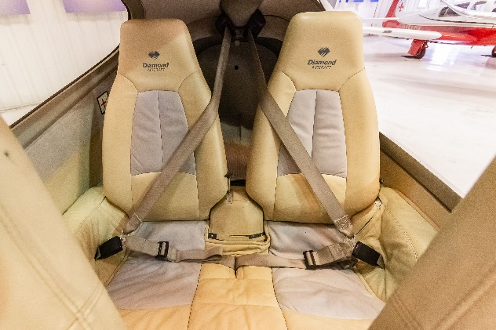
- GARMIN INTEGRATED VFR TERRAIN AWARENESS SYSTEM
- GEA71 AIRFRAME/ENGINE INTERFACE UNIT
- DUAL GARMIN GIA 63 COM/NAV/GPS
- GMA1347 DIGITAL AUDIO SYSTEM
- GTX33 MODE S TRANSPONDER – TRAFFIC SYSTEM
- VFR TERRAIN AWARENESS SYSTEM
- GRS77 SOLID-STATE ATTITUDE HEADING REFERENCE SYSTEM
- GDC74 DIGITAL AIR DATA COMPUTER
- GMU44 MAGNETOMETER
- STANDBY INSTRUMENTS (COMPASS, HORIZON, AIR SPEED INDICATOR, ALTIMETER)
- GARMIN GDL69A – SATELLITE WEATHER AND XM RADIO
- WX500 STORMSCOPE
- ELT ARTEX 406 MHZ

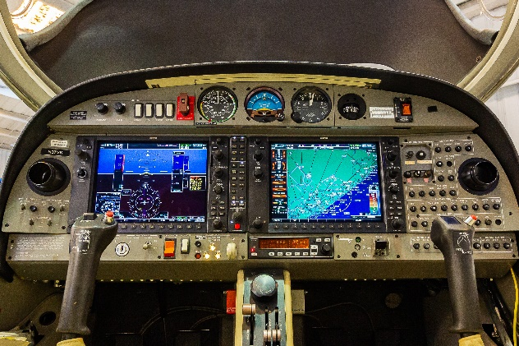
AUTOPILOT
- HONEYWELL KAP140 DUAL AXIS AUTOPILOT WITH ALTITUDE HOLD AND PRESELECT

OPTIONAL EQUIPMENT
- LONG RANGE FUEL TANKS (79 US GALLONS)
- COMPOSITE CABIN AND SAFETY SEATS (UP TO 26G)
- LIGHTNING PROTECTION SYSTEM
- FIRE EXTINGUISHER
- FAILSAFE AIRFRAME DESIGN
- 3 POINT SAFETY BELTS AUTOMATIC (ALL SEATS)
- HYDRAULIC RETRACTABLE LANDING GEAR
- HIGH INTENSITY DISCHARGE LANDING AND TAXI LIGHTS
- POSITION AND ANTI-COLLISION LIGHTS
- 4-WAY BAGGAGE COMPARTMENT SYSTEM
- NOSE BAGGAGE COMPARTMENT ACCESSIBLE FROM BOTH SIDES

