2000 CESSNA CITATION X
N194SR – SN 750-0112
Price: Inquire – TRADES CONSIDERED!

WANT TO GO FAST AND IN STYLE? THIS EXCEPTIONALLY MAINTAINED AND CARED FOR CITATION X WILL TAKE YOU TO THE EDGE OF THE SOUND BARRIER LIKE NO OTHER AIRCRAFT ON THE MARKET!
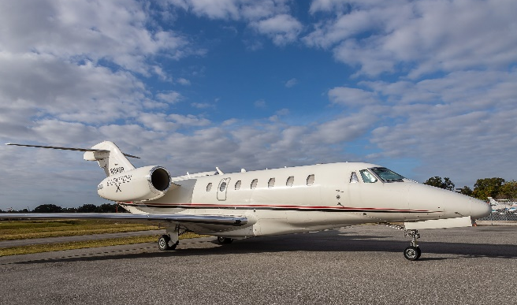

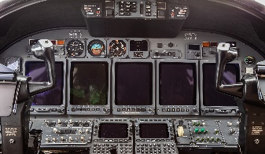
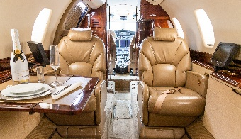

STATUS
TOTAL TIME: AIRFRAME: 5,033 HOURS SINCE NEW, CYCLES: 2,815
ENGINE: 5,033 HOURS SINCE NEW, CYCLES 2,809
APU HOURS: 2,979 HOURS, CYCLES 3,789
PASSENGER SEATING: 8

EXTERIOR
ALL OVER WHITE WITH BLACK AND RED ACCENT STRIPES

INTERIOR
EXECUTIVE CONFIGURATION WITH FORWARD AND AFT CLUB SEATING FOR 8 PASSENGERS, EACH WITH AN ENTERTAINMENT CONTROL AND PERSONAL MONITOR
DUAL (2) DVD/CD PLAYERS
FORWARD GALLEY WITH A MICROWAVE OVEN, COFFEE MAKER AND ESPRESSO MACHINE

AVIONICS
HONEYWELL PRIMUS 2000 WITH 5 TUBE EFIS
ADF: HONEYWELL RNZ-850
AFIS: SATAFIS
COMMUNICATION RADIOS: DUAL HONEYWELL RCZ-833 WITH 8.33 SPACING
NAVIGATION RADIOS: DUAL HONEYWELL RNZ-850 WITH FM IMMUNITY
CVR: FAIRCHILD FA2100
DUAL DME
FMS: DUAL HONEYWELL FMZ-2000 WITH DUAL GPS
HF: DUAL HONEYWELL KHF-950 WITH COLTECH CSD-714 SELCAL
IRS: DUAL HONEYWELL LASEREF IV
RADAR ALTIMETER: HONEYWELL AA-300
SATCOM: AIRCELL AXXESS II IRIDIUM
TAWS: HONEYWELL MARK V EGPWS
TCAS: HONEYWELL TCAS-2000 TCAS II WITH CHANGE 7
TRANSPONDER WITH ENHANCED SURVEILLANCE
WEATHER RADAR: HONEYWELL PRIMUS 880
AUTOPILOT
HONEYWELL PRIMUS 2000 IFCS

ACCESSORY EQUIPMENT
DUAL OXYGEN BOTTLES (EXTENDED RANGE O2)
SINGLE-POINT REFUELING
LEAD ACID BATTERIES
TERRAIN AWARENESS AND WARNING SYSTEM (TAWS)
TRAFFIC COLLISION AVOIDANCE SYSTEM (TCAS II)
SATCOM
COCKPIT VOICE RECORDER (CVR)
8.33 CHANNEL SPACING
AILERON RE-GEARING MOD COMPLETED

MAINTENANCE PROGRAMS
ENGINES ENROLLED ON ROLLS-ROYCE CORPORATE CARE (RRCC)
MAINTENANCE TRACKED BY CESSCOM (CAMP)
RECENT INSPECTIONS COMPLETED AT THE SAN ANTONIO CESSNA SERVICE CENTER

