Delivery time only! Still has the new aircraft smell with a used aircraft price. Air-conditioned, G1000 NXi, Warranty until August 2022 and comes with Mooney transition training and the 3-year free maintenance program Fill and Fly!

STATUS
- Total time, airframe: 40 hours since new
- Engine: 40 hours since new
- Propeller: 40 hours since new
- Warranty until august 2022 or 300 hours

EXTERIOR/INTERIOR
- Snow white, slate gray pearl with light rich blue metallic
- Grey leather interior

AVIONICS
- GDU 1054, 10” primary flight display, three axis flight dynamics, air speed, altitude, VS, HSI with perspective modes with flight stream 510
- GDU 1054, 10” multi-function display
- GDC 72 integrated digital air data computer, constant display of TAS, CAS, wind direction, VSI and TAT
- GRS 79 solid-state attitude and heading reference system
- Dual GIA63, WAAS integrated radio modules with IFR approved GPS, VHF navigation with ILS and VHF communication with 16-WATT 8.33-KHZ
- GMA 1347 digital audio controller with integrated marker beacon
- GTX 345R integrated mode-s transponder with traffic and WX info service and ADS-B in/out
- GEA 71 airframe/engine interface unit
- GMU 44 magnetometer
- Garmin “smart pad” keypad integrated to the G1000
- Artex me406 ELT
- Mid-continent MD302 all-in-one electronic stand-by instrument with independent internal battery back-up
- Garmin vertical nav (coupled VNAV) enroute and approach
- Jeppesen charts and SafeTaxi (1st year subscription included)
- Garmin GDL 69A, XM radio and XM weather (1st year subscription included)
- Garmin terrain warning system
- Synthetic vision (SVT)

AUTOPILOT
- Garmin GFC700 fully integrated autopilot and flight director
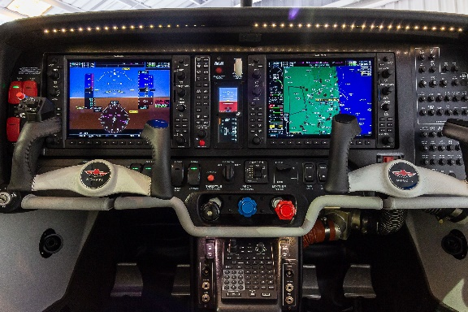
airframe features
- AmSafe airbag seat belts (2 places) - pilot and copilot
- Installation of hot-wire plugs for Bose - (4 place) pilot, copilot and passengers
- Tinted aft windows
- 3” rudder pedal extensions
- Oxygen system (77.1 cubic foot) and four masks
- Xenon landing and taxi lights
- Second alternator stand-by, dual bus system
- Fuel capacity – 100 USG useable
- Precise flight speed brakes
- Freon air conditioning
- 3-year standard warranty (airframe, engine, and avionics)
- Factory trasition training (pilot only)

FILL & FLY PROGRAM
- 3 years/1,000-hour factory warranty
- All consumables (except for fuel) covered for 3 years/300-hours including annual inspections
- $10,000 voucher for additional flight training of your choosing
