SVT!
2008 Cessna 182T Skylane with G1000, GFC700, WAAS
N6187J Ser#18282094

289 Total Time Since New

Avionics:
GMA-1347 Digital Audio Panel with Marker Beacon/Intercom
GTX-33 Mode S Transponder with TIS
GIA-63W NAV/COM/GPS/WAAS with Glideslope #1
GIA-63W NAV/COM/GPS/WAAS with Glideslope #2
GDU-1044B Primary Flight Display (PFD)
GDU-1044B Multi-function Display (MFD)
GEA-71 Engine/Airframe Computer
GRS-77 AHRS
GDC-74A Air Data Computer with OAT Probe
GMU-44 Magnetometer
Garmin SafeTaxi & FlightCharts
GFC-700 Autopilot
• Go-Around Switch
• Electric Trim
• Autopilot Disconnect
• Control Wheel Steering Button
GDL-69A Flight Information System (FIS) with XM Radio
WX-500 Stormscope
Electronic Checklists
ME-406 Two Frequency Emergency Locator Transmitter
Emergency Locator Transmitter Remote Mounted Switch
Backup Attitude Gyro, Altimeter and Airspeed Indicator
Control Wheel Push-To-Talk Switch - Pilot/Copilot
Mic & Phone Jacks - Pilot/Copilot/Passengers
Auxiliary Stereo Input Jack
Antennas:
• Marker Beacon Antenna
• Transponder Antenna
• VHF/GPS Antenna (2)
• XM Antenna
• NAV Antenna
• Emergency Locator Transmitter External Antenna
• Stormscope Antenna
Pitot System - Heated
Static System
Hand Held Microphone
Alternate Static Source
Compass
Mode S Transponder
Digital Audio Panel with Audio Playback
Traffic Information System (TIS)
Terrain and Obstacle Mapping (Topographic and Relative)
XM Satellite Weather Radio (subscription required)
Stormscope System - WX500
Garmin GFC700 Fully Integrated Two-axis Autopilot
Backup Airspeed, Attitude and Altimeter - Standby Battery
AmSafe Inflatable Seat Belts & Shoulder Harness STC, Inertia Reel, Pilot/Co-Pilot/Passenger Seats 3 & 4

Additional Equipment:
SVT

Exterior:
Matterhorn White with Parade Blue Pearl and Cumulus Gray Pearl Painted Stripes.

Interior:
Leather Seat Surfaces, Pebble Leather with Perforated Pebble Leather Insert / Pebble Vinyl
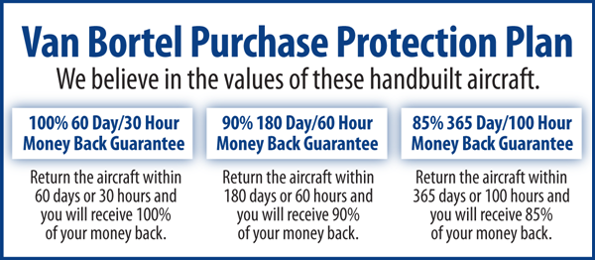

We fly the aircraft to your ramp for inspection by you and your mechanic at no cost or obligation to you.

All Specifications Subject To Verification Upon Inspection

Trades Welcome • No Damage History • Always Hangared • No Corrosion

