Only Mirage on the market with zero since major overhaul with warranty, new style motor mounts and new style fuel senders! Low total time, no damage history with excellent maintenance history – ADS B, WAAS and Long-Range Tanks and Premier Training Package

STATUS
- Total time, airframe: 1,821 hours
- Engine: Zero since major by Certified Aircraft Engines in Miami, Florida (one of the country’s oldest and respected Lycoming overhaulers).
- Propeller: 446 hours since overhaul, 2014 (6-year recommended overhaul)
- Annual: in process
- Useful load: 1,228 pounds
- Complete logs, excellent maintenance and records
- New battery, new style motor mount and new style fuel senders
- No damage history

EXTERIOR/INTERIOR
- Exterior trim: Off-white over maroon metallic with gold accent stripes – Superb condition!
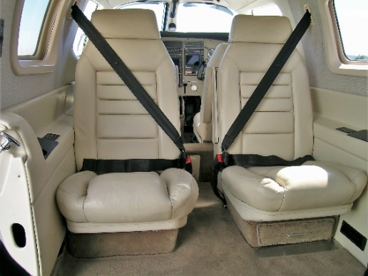
- Interior: Topaz tan leather seats and side panels, club seating – Excellent condition!

AVIONICS
- Upgraded Garmin/S-TEC avionics package including:
- Garmin GMA 340 audio panel with marker beacon and intercom
- Dual GNS-530W high-resolution LCD multi-function display with integrated NAV/COM/GPS, 16” color moving map and dual glideslope
- Situational awareness package (includes Skywatch TCAS Active Traffic System and WX500 Stormscope)
- Upgraded Garmin GMX 200 multifunction display – shows radar, XM weather, WX 500 Stormscope and terrain awareness
- King RDR2000 vertical profile radar
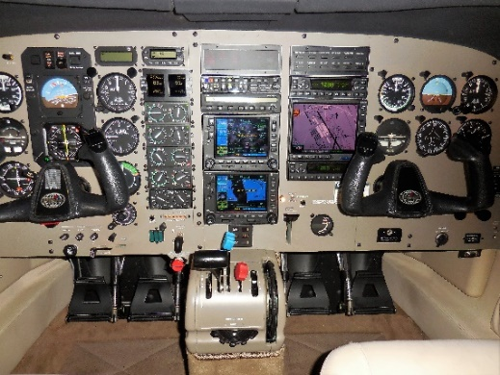
- Garmin GDL 69 XM weather receiver
- Garmin GTX 330 ES ADS B out transponder
- Copilot instruments
- Bose headset pilot and copilot interfaces

AUTOPILOT
- S-TEC 55X Dual-Axis Autopilot with automatic trim with Yaw Damper, Altitude Pre-Select and Alert

ADDITIONAL EQUIPMENT
- Certified for flight into known icing
- Air conditioning
- Transcoil engine gauges
- VK extended range fuel tanks (140 gals)
- Forward refreshment center/storage
- Clarion stereos AM/FM/CD player
