Fully equipped Bell 407 GXP with autopilot, corporate interior,

air conditioning and much more!

One owner since new. Always maintained at Bell Authorized Service Center. Priced to sell!
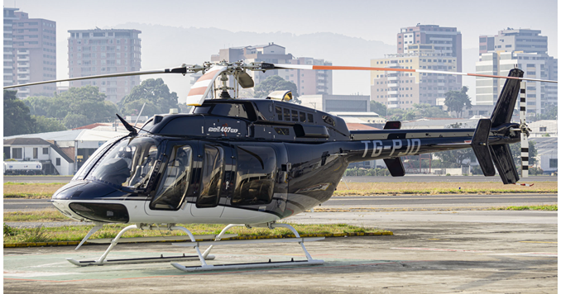

general

Airframe total time: 762.5 hours

Engine: 762.5 hours
- Engine cycles: CSN 1218 cycles
- Annual inspection due: January 2021
- Description: no damage history

AIRFRAME
- Corporate configuration
- Leather interior
- Crew grab handle
- Baggage edge protector
- Egress tool

AVIONICS
- G1000H
- Display Unit GDU 1040H (PFD)
- Display Unit GDU 1040H (MFD)
- Engine Signal Processor GEA 71H
- Air Data GDC 74H

- Magnetometer MGU-44
- VHF#1 Radio GIA 63H
- VHF #2 Radio GIA 63H
- Audio Panel Pilot GMA 350H
- Transponder GTX-33H
- ELT C406-NHM
- Radar Altimeter TRA 4500
- TAS Processor GTS 800
- XM Transceiver GDL-69
- Autopilot computer
- Autopilot controller
- Autopilot pitch servo
- Autopilot roll servo
- Autopilot pitch SCAS
- Autopilot rolls SCAS
- Tail boom antenna mount

- OAT Probe GTP 59
- ADAHRS Unit GRS 77H

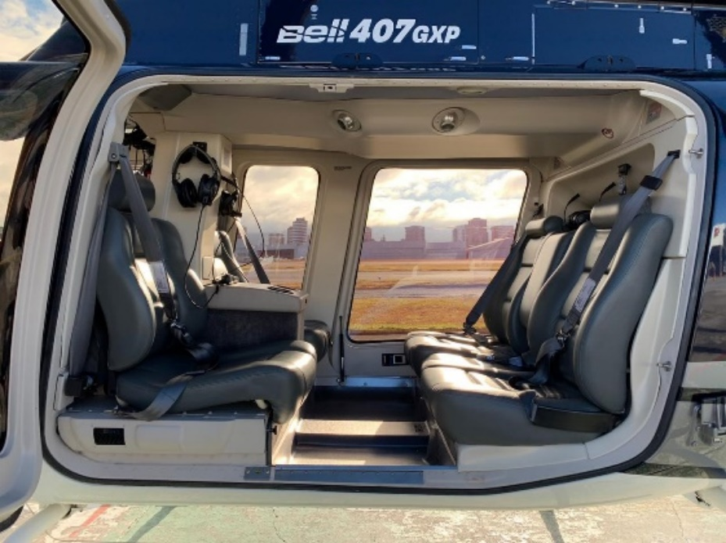
KIT LISTING
- Aft avionic shelf
- Radar Altimeter RA-4500
- TAS GTS 800
- XM Weather GDL-69A
- ELT w PGM C406-N HM
- Tail rotor camera
- Autopilot
- 28 AmpH Battery
- Increased starter / generator load kit
- Soundproofing – corporate
- Armrests – corporate leather
- Headliner with ECS ducts
- Aux fuel tank installation
- High skid gear
- Dual control
- Snow deflectors
- Windows sliding
- Max gross weight
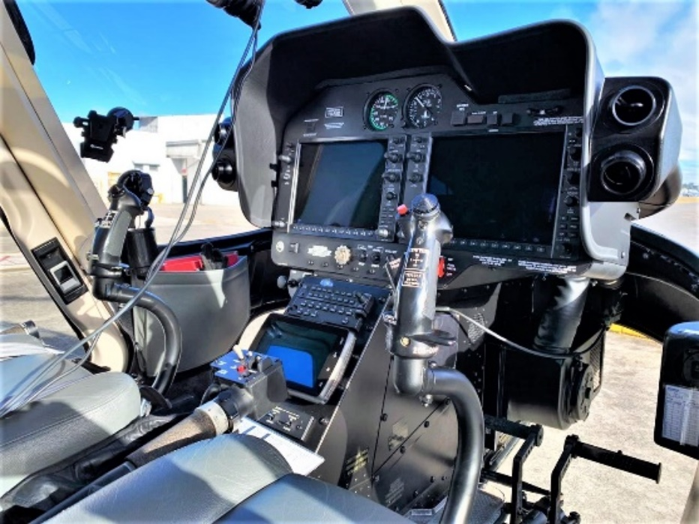
- Quiet mode
- Overspeed adapter
- Engine inlet barrier filter
- Door opener, baggage
- Tail rotor pedal lockout kit
- Mount antenna tail boom
- Flitesteps
- Floor protector kit
- Baggage floor protector
- Door opener, cabin
- Pre-flight step/handle kit
- Folding maintenance step
- Door opener, high visibility
- High-visibility crew door kit
- High-visibility cabin door kit
- Locking fuel cap kit
- Air conditioner - dual forward evaporator
- USB adapter
- Tail rotor pedal lockout kit

