2015 Garmin G2000 Cessna T240 TTx |  |  |  | N667CS | Serial Number: |  | T24002067
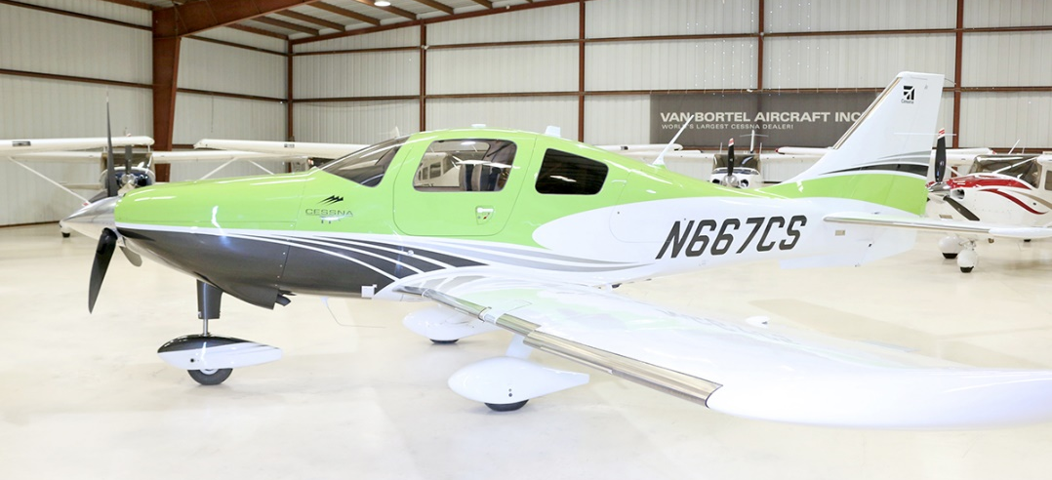
302 Total Time
 |  |  |  | Blaze Seats
Standard Empty Weight: 2535 lbs |  |  |  | 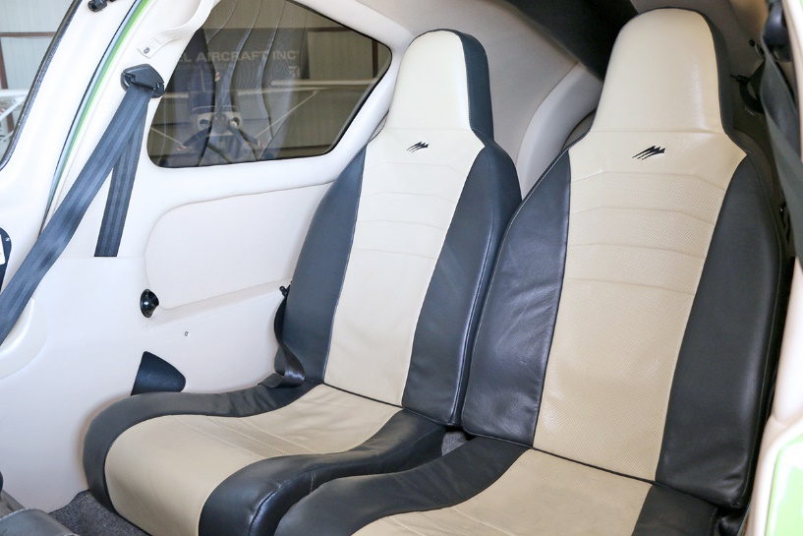
Exterior:
Ascent Green Apple
Interior:
Blaze Shell Interior
Blaze Two-Tone
Systems:
TKS Flight Into Known Ice (FIKI)
Air Conditioning
Avionics:
Garmin GTS800 Traffic Advisory System (TAS)
Garmin TAWS-B Terrain Awareness and Warning System
Garmin GDL69A XM Weather & Radio
Two Year Extension to Premium OEM
Aircraft Engine Warranty |  |  |  | Standard Avionics Features - Garmin G2000 with Electronic Stability Protection (ESP)
Synthetic Vision (SVT)
GMA36 - Remote Digital Audio Panel
GTC570 - Touch Screen Controller
GTX33ES - Remote Transponder w/ Mode S & ADS-B out
Dual GIA63W – Integrated NAV/COM/WAAS GPS
GDU1400 – Primary Flight Display
GDU1400 – Multi Function Display
GEA71 – Engine Airframe Interface
Dual GRS77 – Attitude & Heading Reference System
GDC74A Air Data Computer w/OAT Probe
Dual GMU44 Magnetometer
GCU275 Primary Flight Display Controller
Electronic Checklist
GFC700 Autopilot
- GMC720 Autopilot Controller
- Go-Around Switch w/Coupled Missed Approach Capability
- Control Wheel Steering
- Electric Trim
- Electronic Stability Protection (ESP)
Garmin Safe Taxi
Garmin Flite Charts (Geo-Synchronous Positioning)
Stormscope

 |  |  |  | Additional Equipment:  L-3 Trilogy ESI1000 Standby Attitude, Airspeed, Altitude & Heading  Control Stick Push To Talk Switch – Pilot & Co-Pilot  Standard & “Bose” Headset Jacks  CO Detector  Pulse Oximeter  Artex ME406 ELT  Auxiliary Audio Input  Precise Flight Built-In, 4 Place Oxygen |  | Lighted Entrance Step  Dual 12 Volt Power Outlets  Speed Brakes  Inflatable Door Seals  Rosen Sun Visors  Tanis Engine Preheater  Reiff Heater  Warranty Status:  Airframe: 12/16/2020  Power Plant: 12/16/2020

