RECENT ENGINE AND PROP OVERHAUL • NEW AVIONICS PACKAGE INCLUDING GARMIN GTN750 TOUCHSCREEN AND GTX345R • ADS-B IN AND OUT • OSBORNE TIP TANKS EXTRAORDINARILY WELL-KEPT AIRPLANE • ALL SERVICE RECORDS SINCE NEW!

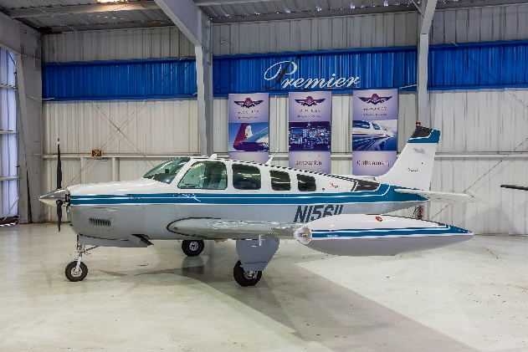
STATUS
- TOTAL TIME, AIRFRAME: 1,915 HOURS SINCE NEW
- ENGINE: 40 HOURS SINCE MAJOR OVERHAUL BY CERTIFIED
AIRCRAFT ENGINES
- PROPELLER: 40 HOURS SINCE MAJOR OVERHAUL
- ANNUAL: LAST JUNE 2018, FRESH ANNUAL WITH SALE
- NO KNOWN DAMAGE HISTORY
- USEFUL LOAD 1,323 POUNDS

EXTERIOR/INTERIOR
- MATTERHORN WHITE OVER PAVONNE BLUE AND
MEDIUM GRAY WITH CHARCOAL ACCENTS
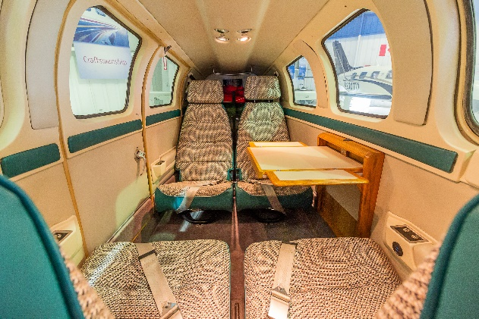
- GRAY AND BLUE FABRIC AND LEATHER INTERIOR
- ORIGINAL INTERIOR IN LIKE NEW CONDITION
- TINTED WINDOW INSERTS

AVIONICS
- NEW GARMIN GTN 750 GPS/COM/NAV/WAAS
- NEW GARMIN GNC 225A VHF NAV.COMM
- NEW GARMIN GTX 345 TRANSPONDER; ADS-B IN/OUT
- NEW GARMIN GMA345 AUDIO PANEL/INTERCOM WITH BLUETOOTH CONNECTIVITY
- BFG WX 950 STORMSCOPE
- KING KCS 55 HORIZONTAL SITUATION INDICATOR
- KING KN63 DME
- NEW STRATUS USB PORT (COCKPIT AND CABIN)
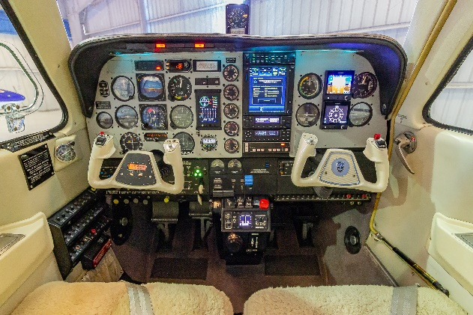
- NEW GARMIN FLIGHTSTREAM 510, BLUETOOTH CONNECTIVITY TO GTN750 AND GTX345

AUTOPILOT
- KING KFC 150 AUTOPILOT WITH ALTITUDE PRE-SELECT
AND FLIGHT DIRECTOR

ADDITIONAL EQUIPMENT
- FULL RIGHT-HAND PANEL WITH GARMIN G5 ELECTRONIC ATTITUDE AND H.S.I.
- JPI EDM-830 ENGINE ANALYZER
- PULSE LIGHTS
- LED POSITION AND STROBE LIGHTS
- OSBORNE TIP TANKS – ADDITIONAL 40 US GAL
- GROSS WEIGHT INCREASE

