Diamond 2022 DA42-VI, call for optional equipment and delivery pricing

POWER PLANT
- 2x Austro Engine AE 300 Turbocharged Common-rail Injected 2.0 Liter Diesel Engine with 168 HP and EECU Single Lever Control System
- 2x MT Propeller MTV-6-R-C-F/CF 190-69 3-Blade Constant Speed Propeller

EXTERIOR SANDARD EQUIPMENT
- Hydraulic Retractable Landing Gear
- Heated Pitot Tube
- High-gloss Multilayer Paint Non-RIM (white)
- Variety of Exterior Striping Options
- White Spinner, Black Air Intake Rings, White Entry Steps and Entry Grips
- Registration Markings
- Electrically Operated Flap System
- Landing and Taxi Lights (Xenon)
- Position and Strobe Lights with LED Technology
INTERIOR
- Diamond Depart Interior (light grey or dark grey)
- Ergonomic Seats and Backrests, Fabric Inlays, Carbon on Transmission Tunnel
- Adjustable Backrest for Pilot and Co-pilot (with adjustable lumbar support)
- Sun Glare Shields and Canopy Lining
- 1x USB Port Each for Pilot and Co-pilot
- Instrument Lighting
- Overhead Cabin Light
- Dual Headset Plugs (LEMO & Standard)

AVIONICS
- Integrated Garmin G1000 NXi Glass Panel Cockpit, including:
- 2x Garmin GDU 105x 10-Inch Flight Display (PFD and MFD)
- Garmin GEA 71B Airframe/Engine Interface Unit
- 2x Garmin GIA 64W COM/NAV/SBAS-GPS/GS/LOC
- Garmin GMA 1360 Digital Audio System
- Garmin GRS 79 Attitude Heading Reference System
- Garmin GDC 72 Digital Air Data Computer
- Garmin GMU 44 Magnetometer
- Garmin GFC 700 Automatic Flight Control System Including Yaw Damper
- Garmin GTX 335 R Remote ADS-B Out Transponder
- Garmin ChartView Approach Plates (subscription required)
- ELT 406 MHz
- Standby Instruments (compass, attitude indicator, air speed indicator (kts), altitude indicator (ft))
- Jeppesen PilotPak (IFR Bundle), one year free subscription

SAFETY CONCEPT
- Composite Cabin and Safety Seats (up to 26g)
- “FAILSAFE” Airframe and Wing design
- Lightning Protection System
- 3-Point Safety Belts Automatic (all seats)
- Garmin ESP (electronic stability and protection)
- Gear Warning Horn Muting System
- Stick Limiter
OTHER EQUIPMENT- STANDARD
- 76.4 US gal (289 lt) Long Range Fuel Tank
- Baggage Extension with Separate Compartment
- Nose Baggage Compartment Accessible from Both Sides
- Pitot Cover
- Control Gust Lock
- Tow Bar
- Tool Kit
- First Aid Kit, Fire Extinguisher, Emergency Axe
- Standard Cockpit Colour: Black

FACTORY WARRANTY & TRAINING
- Two-year factory warranty
- PistonPower airframe and engine maintenance program available at additional cost – call for details
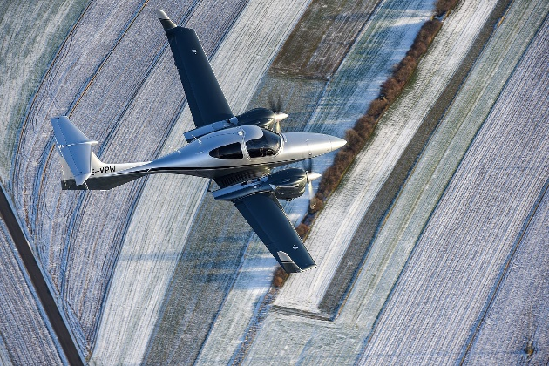
- Factory-approved familiarization training

