BEST EQUIPPED TC ON THE MARKET • TKS AND FACTORY AIR!
ADS-B, WAAS, LIKE NEW INSIDE AND OUT! NO DAMAGE HISTORY!

STATUS

TOTAL TIME AIRFRAME: 1,500 HOURS

ENGINE: 1,500 HOURS

PROP: 0 HOURS SINCE PROPELLER OVERHAUL

ANNUAL: MAY 2019 BY PREMIER AIRCRAFT SERVICE

IFR CERTIFICATION: DUE OCTOBER 2020

NO DAMAGE HISTORY

EXTERIOR/INTERIOR – EXCELLENT CONDITION!
- NEAR NEW CONDITION AND STUNNING COLORS — BRIGHT WHITE OVER MEDIUM CONCORD BLUE METALLIC WITH CUMULUS GREY METALLIC STRIPES

FRONT SEATS — BEIGE LEATHER

SHEEPSKIN COVERS ON FRONT SEATS

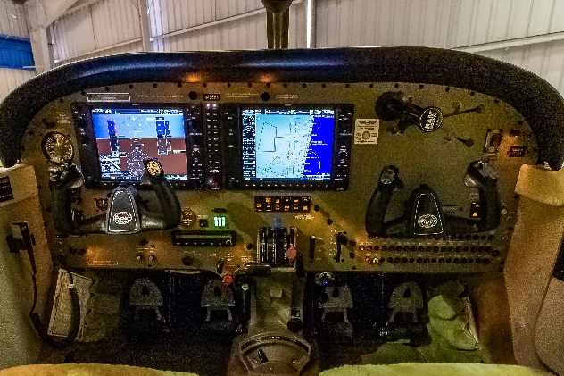
BACK SEATS ALL LIKE NEW! BEIGE LEATHER SEATS WITH MATCHING CARPETING, SIDE PANELS AND WRITING TABLE

MIDDLE REFRESHMENT CENTER WITH IGLOO COOLER

AVIONICS – HIGHLY UPGRADED!
- GARMIN G1000 EQUIPPED
- GARMIN GMA 1347 AUDIO PANEL
- GARMIN GIA 63W, WAAS/GPS/NAV/COM
- GARMIN GTX 33 MODE S TRANSPONDER
- GARMIN GDU 1040 PFD/MFD
- STORMSCOPE – WX500
- SKYWATCH 497
- TERRAIN AWARENESS SYSTEM
- GDL 69 WEATHER AND TRAFFIC (SUBSCRIPTION REQUIRED)
- ADS-B EQUIPPED
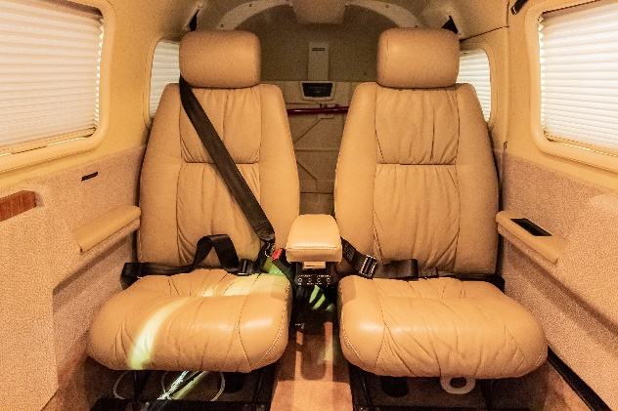
- THREE STANDBY INSTRUMENTS

AUTOPILOT
- STEC 55X WITH ALTITUDE PRESELECT/VERTICAL SPEED SELECTOR

ADDITIONAL EQUIPMENT
- ARTEX 406 MHZ ELT
- KNOTS 2 U GAP SEALS
- BOSE HEAD SET JACKS
- FACTORY OXYGEN SYSTEM
- FACTORY AIR CONDITIONING
- TKS ICE PROTECTION SYSTEM
- LOPRESTI BOOM BEAM LIGHTS

