Tip Tanks! Float Kit!
2006 Cessna T206H Turbo Stationair with G1000
N6060N Ser#T20608658

585 Total Time Since New

Avionics:
GDU-1040 Primary Flight Display (PFD)
GDU-1040 Multi-function Display (MFD)
GMA-1347 Digital Audio Panel with Marker Beacon/Intercom
CI-102 Marker Beacon Antenna
GIA-63 NAV/COM/GPS with Glideslope #1
GIA-63 NAV/COM/GPS with Glideslope #2
CI-2480 VHF/GPS Antenna with Internal Notch Filter (2)
CI-120 NAV Antenna
GTX-33 Transponder - Mode S with TIS
CI-105 Transponder Antenna
GEA-71 Engine/Airframe Computer
• CHT/EGT Sensors - All Cylinders
• Fuel Flow Meter
• Manifold/Tachometer/Vacuum Sensors
GRS-77 AHRS
GDC-74 Air Data Computer with OAT Probe
GMU-44 Magnetometer
KAP-140 Dual Axis Autopilot
• Altitude Preselect
• GPS Roll Steering
• KCM-100 Configuration Mode
• KS-270C Pitch Axis Servo Actuator
• KS-271C Roll Axis Servo Actuator
• KS-272C Pitch Trim Servo Actuator
3000-11 Emergency Locator Transmitter
Emergency Locator Transmitter External Antenna
Emergency Locator Transmitter Remote Mounted Switch
WX-500 Stormscope
NY-163 Stormscope Antenna
Control Wheel Push-To-Talk Switch - Pilot/Copilot
Mic & Phone Jacks - Pilot/Copilot/Passengers
Auxiliary Stereo Input Jack
Blind Turn Coordinator for KAP-140
Avionics Circuit Breaker Panel
Single Engine Driven Vacuum Pump System
Backup Mechanical Instruments
• Attitude (Vacuum Gyro)
• Airspeed
• Altimeter
Magnetic Compass
Pitot System - Heated
Static System
Alternate Static Source
Audible Stall Warning System - Heated
Deck Skin Cooling Fan #1
Avionics Cooling Fan #2 - PFD
Avionics Cooling Fan #3 - MFD
Aft Avionics Cooling Fan #4
GDL-69A XM Satellite Data / Radio Receiver
AmSafe Inflatable Seat Belts & Shoulder Harness STC, Inertia Reel, Pilot/Co-Pilot/Passenger Seats 3 & 4

Additional Equipment:
Tip Tanks
Floatplane Provision Kit
Hot Prop
Built In Oxygen

Exterior:
Matterhorn White with Squadron Blue, Medium Silver and Balboa Blue Painted Stripes

Interior:
Leather Seat Surfaces, Pebble Leather with Perforated Pebble Leather Insert / Pebble Vinyl

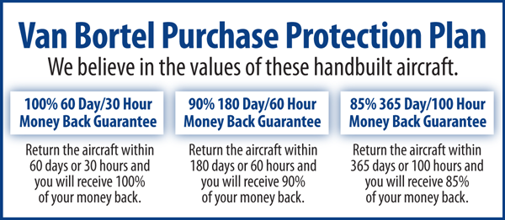

We fly the aircraft to your ramp for inspection by you
and your mechanic at no cost or obligation to you.

All Specifications Subject To Verification Upon Inspection

Trades Welcome • No Damage History • Always Hangared • No Corrosion

