One of the lowest time, VIP configured 407 on the market. Impeccable maintenance by
a Bell authorized service center.
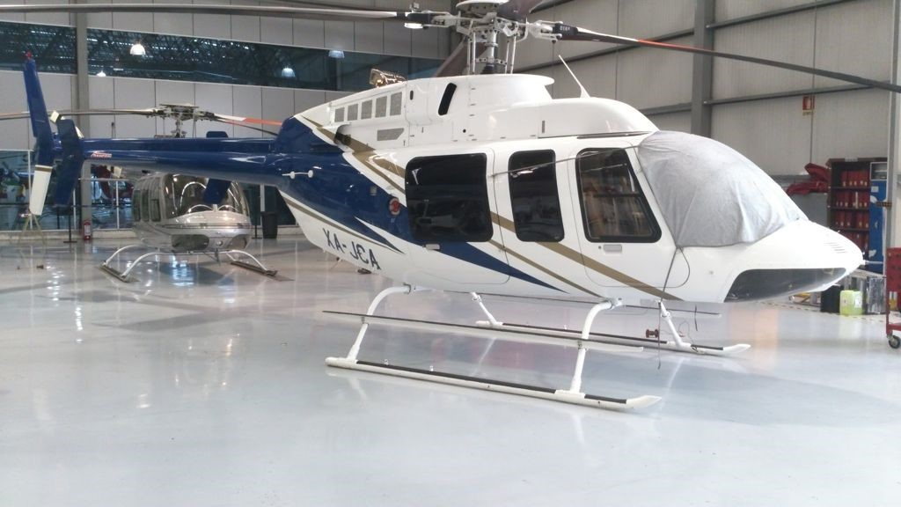

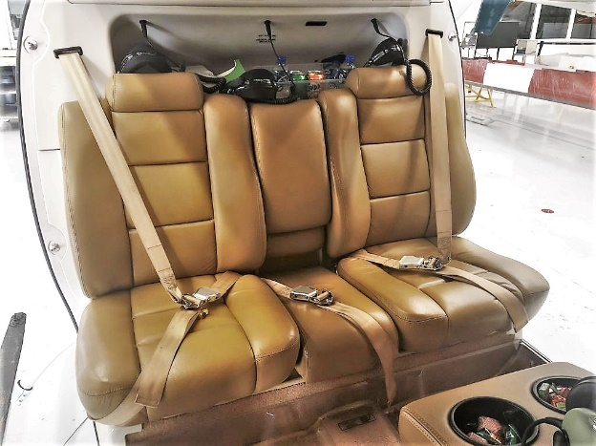

general

Airframe total time: 835.1 hours

Engine: 800.9 hours

EXTERIOR/INTERIOR
- Exterior trim: All over white with gold and blue accent stripes
- Interior: VIP Seating for 5 plus 2 Crew in Tan leather

AVIONICS

Bendix King KT76C transponder

Garmin / GNS430W VHF COMM/NAV/GPS/VOR
- Mid. Continent / 4300‐311 Altitude Indicator
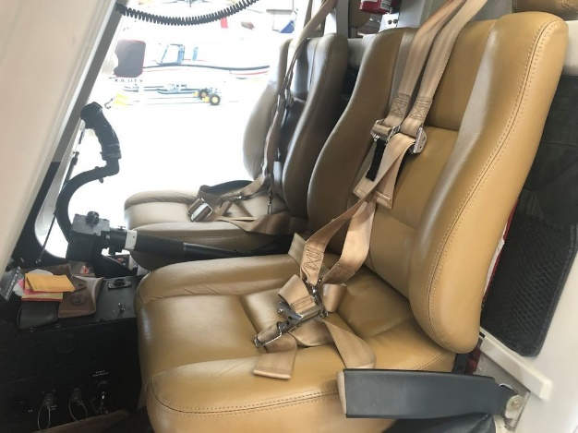
- Mid. Continent / 3300‐11 Directional Gyro
- Bendix King / KY0196A VHF Communication
- Mid. Continent / 5550‐8340N5L Turn & Slip
- PS Engineering Inc / PMA7000B Audio Selector
- Trans‐Cal Industries / SSD130‐30N‐RS232 Altitude Encoder

ADDITIONAL EQUIPMENT
- Flight Step
- High skid gear cross tubes assembly
- Skid tubes assembly
- Air Conditioner System
- Inlet Barrier Filter System

ENGINE
Series CAE‐848368, TSN 800.9 hours

DESCRIPTION | PART NUMBER | TSN | REM
Turbine | 23063354 | 835.1 | 1164.9 hrs
1 st stage wheel | 23074361 | 835.1 hrs / 1147 cyc | 1189.9 hrs / 1853 cyc
2 nd stage wheel | 23074362 | 835.1 hrs / 1147 cyc | 1189.9 hrs / 1853 cyc
3 rd stage wheel | 23092511 | 835.1 hrs / 1147 cyc | 3714.9 hrs / 4853 cyc
4 th stage Wheel Impeller | 23066744 | 835.1 hrs / 1147 cyc | 3714.9 hrs / 4853 cyc
Fuel Nozzle | 23065591 | 835.1 hrs / 1147 cyc | 6664.9 hrs / 13853 cyc
HMU | 23077067 | 835.1 | 1164.9 hrs
Bleed Valve | M250‐10239 | 835.1 | 1664.9 hrs
Turbine | 23073353 | 835.1 | 664.9 hrs

AIRFRAME

DESCRIPTION | PART NUMBER | TSN | REM
Main Rotor Hub | 407-010-100-123 | 835.1 | 1664.9 hrs
MR Blades (4 ea) | 407-015-001-137 | 835.1 | Cond
Transmission | 407-040-006-123 | 835.1 | 4164.9 hrs / Ago 2021
Mast Assy | 407-040-011-111 | 835.1 | 1664.9 hrs / Ago 2021
Swashplate & Support | 406-010-401-117 | 835.1 | 1664.9 hrs
Freewheel | 406-040-500-147 | 835.1 | 2164.9 hrs / Ago 2021
T/R Gearbox | 406-040-400-121 | 835.1 | 4164.9 hrs / Ago 2021
T/R Hub | 407-012-101-113 | 835.1 | 1664.9 hrs
T/R Blades (2 ea) | 406-016-100-119 | 835.1 | Cond

INSPECTIONS, AD, ASB

APPLICABLE | EVENT/ SERVICE
850 hrs. | 50 hrs. Inspection to Air Conditioning System Ref. 407EC‐200M‐2
May 2021 | Monthly Inspection Fire Extinguisher Cabin Ref.BHT‐407‐MPI DMC‐407‐A‐26‐20‐00‐01A‐280A‐A and DMC‐407‐A‐12‐00‐00‐10A‐200A‐A
May 2021 | Monthly Update GPS Ref. GARMIN
May 2021 | 50 hrs. / 3 Month Grease Lubrication
May 2021 | 300 hrs. / 3 Month Grease Lubrication
May 2021 | 100 hrs. / 90 Day Corrosion Control Guide

BULLETINS/DIRECTIVES
- ASB 407-19-122 Last submitted bulletin from the manufacturer and applied to the aircraft
- AD 2019-08-10 LAST DIRECTIVE SUBMITTED BY THE FAA AND APPLIED TO THE AIRCRAFT

