Absolutely Pristine and Beautifully Equipped Meridian Has Everything You Want! $75,000 Gross Weight Increase Kit and over $175,000 of Avionics Upgrades!! Garmin Glass with Touchscreen GPS and Much More! Always Hangared—Superb Condition! Trades Welcome!

STATUS
- Total time, airframe: only 1,832 hours
- Engine: 1,832 hours and zero since hot section
- Propeller: 528 hours since overhaul – May 2014
- Hartzell 4-Blade Propeller
- Annual: August 2019 per Piper Inspection Guide
- Complete logs – excellent care throughout its life
- No known damage history

EXTERIOR – Excellent Condition!
- White upper over medium Concord blue metallic lower with gray and black accent stripes

INTERIOR – Recently Redone - Superb Condition!
- All seats redone in upgraded quality leather
- Executive seating for six with khaki leather seats and dark blue carpeting and carpet runner
- Refreshment center, stowable table and pilot storage cabinet
- Bose jacks at all six seats
- Seat behind pilot currently removed but available

AVIONICS
- Garmin G500 System:
- Dual G-500s with Synthetic Vision, Radar, WAAS
- GTN 750 WAAS Touchscreen GPS
- Two ADS-B Transponders Garmin GTX-345R with ADS-B In and Out and Garmin 335 with ADS-B Out
- L-3 Trilogy Glass Panel Backup Display
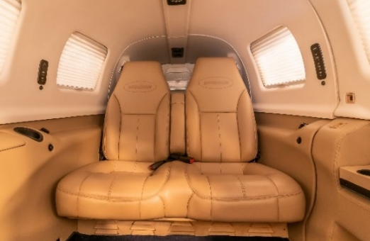
- Garmin GMA 340 Audio Panel
- Garmin 69A XM Weather and Music
- Synthetic vision and radar on pilot’s side
- Honeywell HAS 8000 Traffic, Terrain and Ground Proximity Warning Systems
- WX 500 Stormscope

AUTOPILOT
- Upgraded Magic 1500 Flight Control System with GPSS roll steering and yaw damper S-TEC ST-360 altitude preselect, altitude hold, VOR/LOC/GS coupling, airspeed and pitch climb

ADDITIONAL EQUIPMENT
- Lopresti landing and taxi lights
- LED navigation lights
- 4-12V plugs throughout aircraft
- Extra insulation in floor
- Air conditioning
- Certified for Known Icing
