Everything is Like Brand New Except the Price!
Low Time, Great Maintenance and Dual ADS-B In and Out! Always Hangared, Trades are welcome and we handle insurance, financing, training and delivery! Price includes our Premier training package

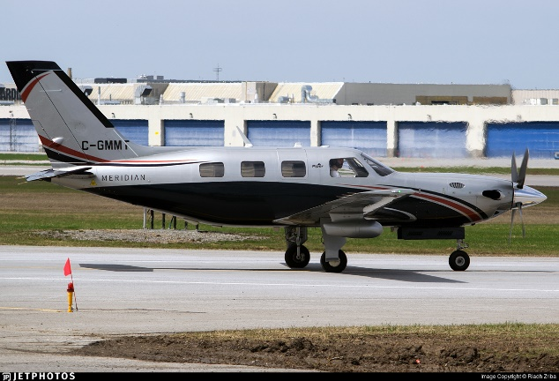
STATUS
- Total time, airframe: only 992 hours
- Propeller: Only 992 hours since new
  - Hartzell HC-E4N-3Q
- Engine: only 992 hours
  - Pratt and Whitney PT6A-42A
  - TBO: 3,600 hours
- Annual completed: November 2019 annual – Midwest Malibu – just passed our prebuy inspection and Borescope
- Useful load: 1,680 pounds

EXTERIOR/INTERIOR
- Titanium blue pearl over Saffron pearl
- Tan leather interior with wool carpeting

AVIONICS
- Garmin G1000 avionics suite with WAAS and synthetic vision:
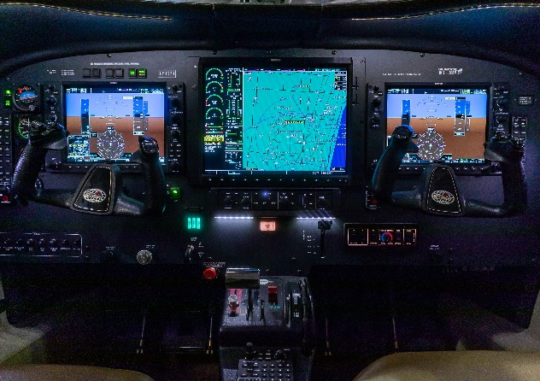
- dual GDU 1040A 10” primary flight display
- 15” multi-function display
- Dual GMA1347 audio panels
- Dual GDC 74a air data computers
- Garmin 345R transponder with ADS-B in and out
- Garmin 335R – second transponder with ADS-B out
- Garmin GWX 68 color radar
- Bendix king KTA 870 active traffic system
- Jeppesen ChartView
- TAWS-B (Terrain Awareness and Warning System)
- Dual Garmin GRS-77 AHRS
- Dual Garmin GMU-44 magnetometers
- GDL-69A satellite radio/weather data receiver
- Digital Standby Attitude Indicator
FILE PHOTO
- WX-500 Stormscope
- Garmin SafeTaxi

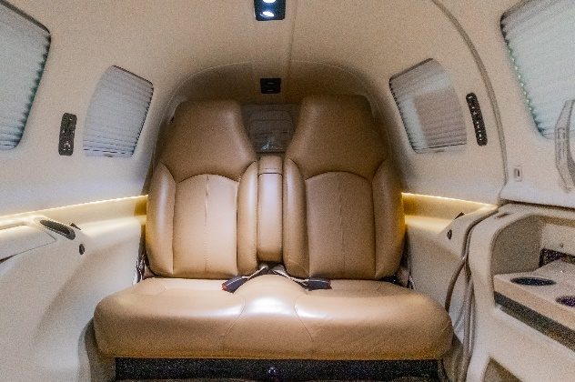
AUTOPILOT

Garmin GFC 710 Autopilot/Flight Director with VNAV Coupling for WAAS Approaches

ADDITIONAL EQUIPMENT
- Known Icing System
- Overhead switch panel
- Piper HFC-134A air-conditioning
- H3R halon fire extinguisher
- Safe flight lift computer
- Artex me 406 mhz ELT
- Compressor wash ring
- Crew alerter system
- Stainless steel cowling fasteners
- Optional LED landing and taxi lights
FILE PHOTO
- Three-position strobe lights
- Dual elevator and rudder controls
- turbine inlets plugs
- relief tube

