This Aircraft is unbelievable! Previous Air Ambulance, Always Flown by Professional Pilots, Low-Time Factory Reman Engines, Complete Original Logbooks

STATUS
- Total time, airframe: 9,516 hours
- Left engine time: 228 SFRM
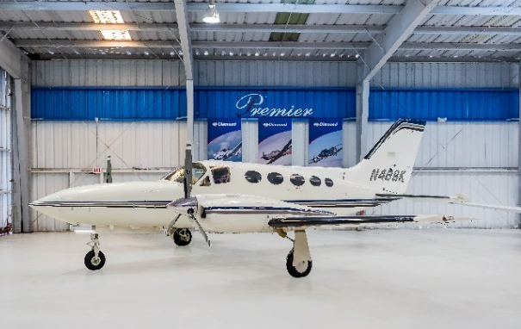
- Right engine time: 57 SFRM
- Left and right prop: 238 hours SPOH
- Annual: May 2019
- Useful load: 2,433 pounds

EXTERIOR/INTERIOR
- White with blue, grey and black accents
- Beige leather interior
- Belted side facing potty
- Two executive tables
- Aft club seating in main cabin

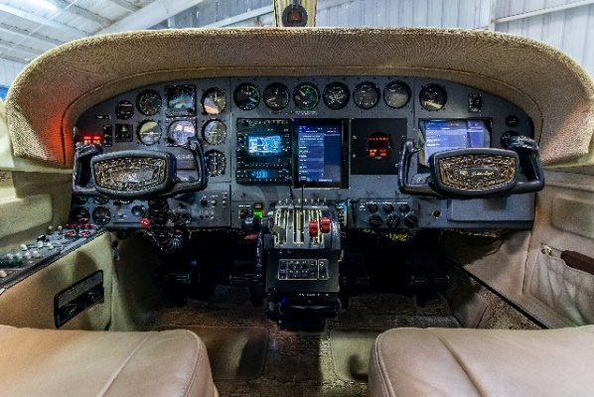
AVIONICS
- KMA20 Audio Panel
- GNS 430W Nav/Com/GPS
- SL30 Nav/Com
- Stratus Appareo XPPR with ADS-B out
- GDL 39 3-D with Nexrad Weather with ADS-B in
- Flight Stream 210
- Dual iPads mounted in panel
- All instrument are Nulite Bezel lighted

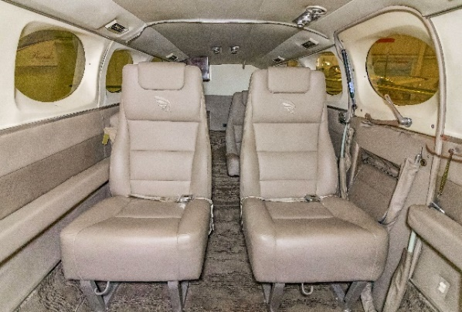
AUTOPILOT
- King KFC 200 with Flight Director and YAW

ADDITIONAL EQUIPMENT
- Known De-Ice
- Navigation lights
- Deice lights on wing
- Wing tip strobe lights
- Electric heated props
- Factory air conditioning
- Performance wheel covers
- Heated stall warning vanes
- Pilot heated glass windshield
- Head dual Pitot/static system
- Dual retractable landing lights
- Factory installed 11 cubic foot oxygen bottle and system
