Brand new $40K extensive Garmin panel upgrade! Desirable three-bladed prop.
Beautiful paint and interior. ADS-B in/out. KAP 150 autopilot with altitude hold.
Nice Dakotas are almost impossible to find.

STATUS
- Total time, airframe: 4,400 total time
- Engine: 1,780 hours since overhaul
- Propeller: 900 hours since prop overhaul
- Annual: March 2020 by Piper Service Center
- Useful load: 1,175 lbs.
- No known damage history

EXTERIOR/INTERIOR
- Cosmetics way above average!
- Exterior trim: overall white with tan and gold
- Interior: recent cream leather with new carpet

AVIONICS
- Garmin 345 audio panel
- Garmin 650xi GPS system
- Garmin GI 275 attitude horizon
- Garmin GI 275 HSI
- King KX 165 NAV/COM
- Garmin flight stream 510
- Stratus ADS-B in/out
- Horizon digital tachometer
- Digital fuel flow
- Gem 602 monitoring system CHT/EGT
- Vertical card compass

AUTOPILOT
- KAP 150 autopilot with altitude hold

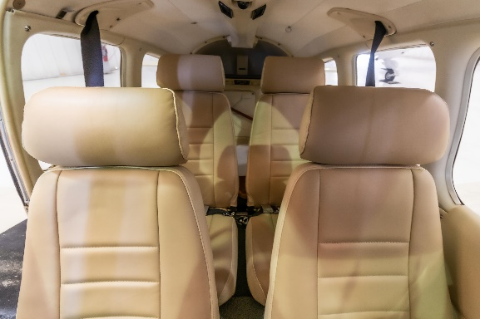
ADDITIONAL EQUIPMENT
- Chrome spinner
- Electric trim
- Wingtip strobes
- Brand new wingtip LED recognition lights
- Brand new LED landing light
- Dual push-to-talk switches
- Dual toe brakes
- Brand new battery
- Avionics master switch
- Hobbs meter
MAINTENANCE
- Recent 500-hour MAG inspection in March 2020
- Recent Piper Service Center comprehensive $11.5 annual inspection
- Piper mandatory wing corrosion inspection service bulletin just completed

