2015 Garmin G2000 Cessna T240 TTx |  |  | N475TZ Serial Number: T24002075
774 Total Time
 |  |  | Dark Seats
Standard Empty Weight: 2535 lbs |  |  | 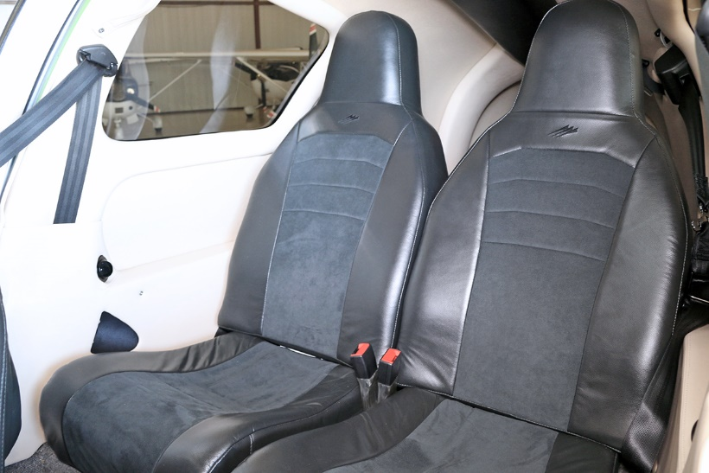
Exterior:
Accent: Green Apple
Interior:
Blaze Shell Interior
Blaze Dark Seat Option
Systems:
TKS Flight Into Known Ice (FIKI)
Air Conditioning
Avionics:
Garmin GTS800 Traffic Advisory System (TAS)
Garmin TAWS-B Terrain Awareness and Warning System |  |  | Standard Avionics Features - Garmin G2000 with Electronic Stability Protection (ESP)
Garmin GDL69A XM Weather & Radio
 |  |  | Synthetic Vision (SVT)  GMA36 - Remote Digital Audio Panel  GTC570 - Touch Screen Controller  GTX33ES - Remote Transponder w/ Mode S & ADS-B out  Dual GIA63W – Integrated NAV/COM/WAAS GPS  GDU1400 – Primary Flight Display  GDU1400 – Multi Function Display  GEA71 – Engine Airframe Interface  Dual GRS77 – Attitude & Heading Reference System  GDC74A Air Data Computer w/OAT Probe  Dual GMU44 Magnetometer  GCU275 Primary Flight Display Controller  Electronic Checklist  GFC700 Autopilot  - GMC720 Autopilot Controller  - Go-Around Switch w/Coupled Missed Approach Capability  - Control Wheel Steering  - Electric Trim  - Electronic Stability Protection (ESP)  Garmin Safe Taxi  Garmin Flite Charts (Geo-Synchronous Positioning) | Additional Equipment:  L-3 Trilogy ESI1000 Standby Attitude, Airspeed, Altitude & Heading  Control Stick Push To Talk Switch – Pilot & Co-Pilot  Standard & “Bose” Headset Jacks  CO Detector  Pulse Oximeter  Artex ME406 ELT  Auxiliary Audio Input  Precise Flight Built-In, 4 Place Oxygen Lighted Entrance Step  Dual 12 Volt Power Outlets  Speed Brakes  Inflatable Door Seals  Rosen Sun Visors  Tanis Engine Preheater  Warranty Status:  Power Plant: 12/23/2020

