One Owner!
Garmin NXi / Flight Stream 510! SVT! Active Traffic (TAS)! XM Weather! WX500! Surface Watch! ADS-B In/Out!
2017 Cessna 182T Skylane with G1000, GFC-700, WAAS, AoA, 95 amp Alternator
N464J Ser#18283013

42 Total Time Since New

Avionics:
Digital Audio Panel w/Marker Beacon/Intercom - GMA 1347
Extended Squitter Transponder with ADS-B Out and In - GTX 345R
NAV/COM/GPS/WAAS w/GS #1 - GIA 63W
NAV/COM/GPS/WAAS w/GS #2 - GIA 63W
Primary Flight Display - GDU 1054B
Multi-Function Display - GDU 1054B
Engine/Airframe Computer - GEA 71
Combined Attitude & Heading Reference System
(AHRS) and Air Data Computer w/OAT Probe - GSU 75
Magnetometer - GMU 44
Garmin SafeTaxi & FliteCharts
Autopilot - GFC 700
Go-Around Switch
Electric Trim
A/P Disconnect
Control Wheel Steering Button
IFR / VFR Aeronautical Charts
Electronic Checklists
Two Frequency Emergency Locator Transmitter - ME 406
Emergency Locator Transmitter Remote Mounted Switch
Backup Attitude Gyro, Altimeter and Airspeed Indicator
Control Wheel Push-To-Talk Switch-Pilot/Copilot
Mic & Phone Jacks-Pilot/Copilot/Passengers
Auxiliary Stereo Input Jack
Antennas:
Marker Beacon Antenna
Transponder Antenna
VHF/GPS Antenna (2)
NAV Antenna
Emergency Locator Transmitter External Antenna
Pitot System - Heated
Static System
Hand Held Microphone
Alternate Static Source
Compass
AmSafe Inflatable Seat Belts & Shoulder Harness STC, Inertia Reel, Pilot/Co-Pilot

Additional Equipment:
Garmin NXi / Flight Stream 510
Garmin TAS (GTS800)
ADS-B In/Out
Synthetic Vision Technology (SVT)
Garmin XM Weather and Radio Data Link (GDL-69)
Garmin Surface Watch
Safe Flight SCC Angle of Attack
95 amp Alternator
Stabilizer Abrasion Boots
Wheel Fairings

Exterior:
Matterhorn White with Medium Concord Pearl and Cumulus Gray Metallic painted stripes

Interior:
Leather Seat Surfaces, Pebble Leather with Perforated Black Leather Insert

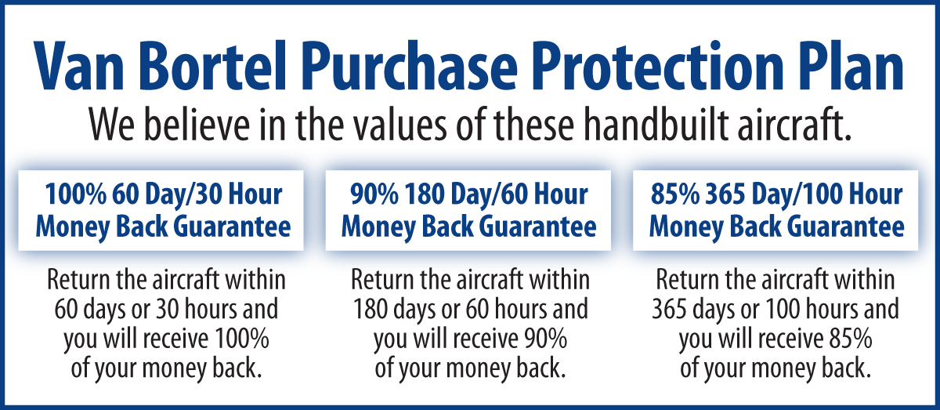
Warranty: 10/12/2019

We fly the aircraft to your ramp for inspection by you
and your mechanic at no cost or obligation to you.

All Specifications Subject To Verification Upon Inspection

Trades Welcome No Damage History Always Hangared No Corrosion

