SVT! Active Traffic (TAS) ADS-B Out!
2007 Cessna T182T Turbo Skylane with G1000, GFC700, WAAS
N802BZ Ser#T18208737

879 Total Time Since New

Avionics:
GDU-1044B Primary Flight Display (PFD)
GDU-1044B Multi-function Display (MFD)
GMA-1347 Digital Audio Panel with Marker Beacon/Intercom
Marker Beacon Antenna
GIA-63W NAV/COM/GPS/WAAS with Glideslope #1
GIA-63W NAV/COM/GPS/WAAS with Glideslope #2
VHF/GPS Antenna
VHF/GPS/XM Antenna
Nav Antenna
GTX-33ES Transponder - Mode S with TIS & ADS-B Out
Transponder Antenna
GEA-71 Engine/Airframe Computer
• CHT/EGT Sensors - All Cylinders
• Fuel Flow Meter
• Manifold/Tachometer/Vacuum Sensors
GRS-77 AHRS
GDC-74 Air Data Computer with OAT Probe
GMU-44 Magnetometer
ME-406 Two Frequency Emergency Locator Transmitter
GFC-700 Autopilot
• Go-Around Switch
• Control Wheel Steering
GDL-69A Flight Information System (FIS) with XM Radio
Emergency Locator Transmitter External Antenna
Emergency Locator Transmitter Remote Mounted Switch
WX-500 Stormscope
NY-163 Stormscope Antenna
Auxiliary Stereo Input Jack
Avionics Circuit Breaker Panel
Control Wheel Push-To-Talk Switch - Pilot/Copilot
Mic & Phone Jacks - Pilot/Copilot/Passengers
Single Engine Driven Pump System
Backup Attitude (Vacuum Gyro), Altimeter and Airspeed Indicator
Magnetic Compass
Pitot System - Heated
Static System
Alternate Static Source
Audible Stall Warning System - Heated
Oxygen System
• Oxygen Bottle - 50 Cu. Ft.
• Oxygen Ports with Masks - Pilot/Copilot/Passengers
• Oxygen Indicator - Overhead Console
• Oxygen Remote Shut-off Valve Control - Overhead Console
McCauley Constant Speed, 3 Blade Propeller with De-Ice Boots
Amsafe Inflatable Seat Belts & Shoulder Harness STC, Inertia Reel, Pilot/Co-Pilot

Additional Equipment:
Synthetic Vision Technology (SVT)
Active Traffic (TAS)
ADS-B Out
Hot Prop
Built in Oxygen

Exterior:
Matterhorn White with Ruby Red Pearl and Antique Gold Pearl Painted Stripes

Interior:
Leather Seat Surfaces: Mink Leather with Perforated Mink Leather Insert / Mink Vinyl

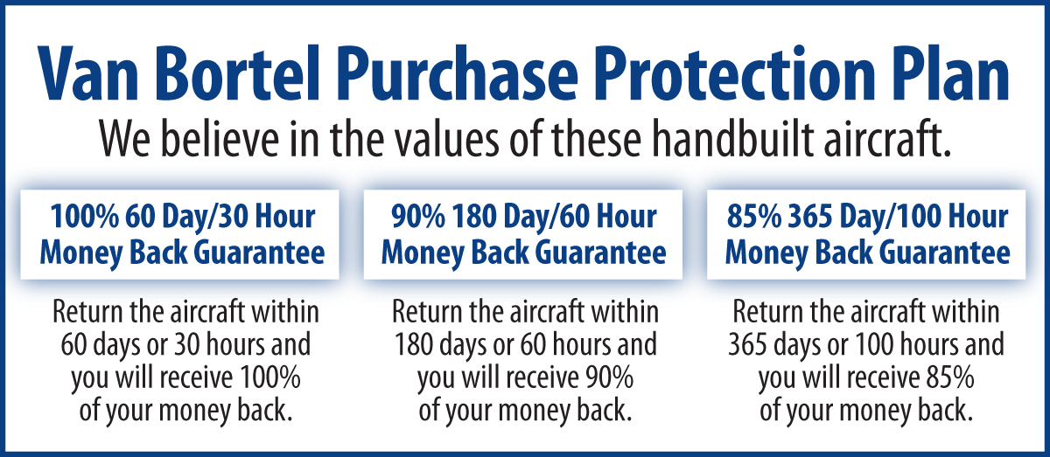

We fly the aircraft to your ramp for inspection by you
and your mechanic at no cost or obligation to you.

All Specifications Subject To Verification Upon Inspection

Trades Welcome • No Damage History • Always Hangared • No Corrosion

