Fully equipped Bell 429 with 7,500lb Gross Weight Increase, 3rd EFIS Screen, Autopilot, VIP Interior, air conditioning, Aux Fuel Tank and much more!

One owner since new. Always maintained at Bell Authorized Service Center. Priced to sell!
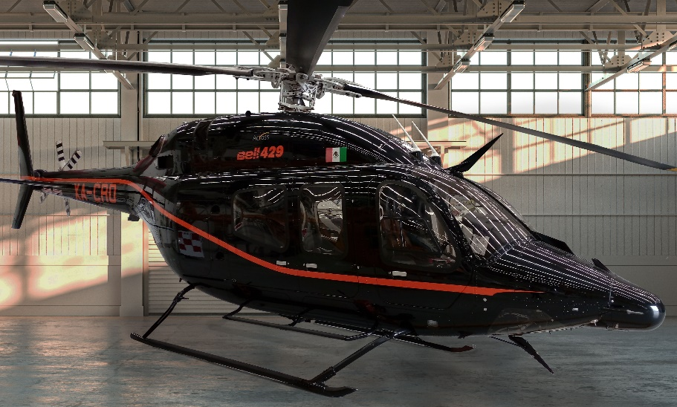

general

Engines total time: 995 hours
- Engine cycles: 3,378 cycles
- No damage history

EXTERIOR/INTERIOR
- High Gloss Black with One Orange accent stripe
- Black leather corporate interior
- VIP Seating for 6/2 crew
- Dual Evaporator Air Conditioning

AVIONICS
- 3rd Display Unit
- Garmin GTN 750 NAV/COMM/GPS
- Garmin GTN 650 NAV/COMM/GPS
- 3-Axis Autopilot
- Avidyne TAS605 Traffic Advisory System
- Curtiss Wright CVR/FDR
- ADS-B OUT
- Dual Bell Standby Compass
- Honeywell Radar Altimeter KRA 405B
- Weather Radar Primus 660
- Helicopter Terrain Awareness and Avoidance System

INSTALLED EQUIPMENT
- Wire Strike Protection System
- 7,500 lb (3402 kg) Gross Weight Increase
- Dual 200 Amp Starter Generator
- Dual Evaporator Air Conditioning System
- Door Opener Kit & Floor Protector
- Dual Inlet Barrier Filter Installation
- Compressor Wash Kit Installation
- Soundproofing Kit Installation
- Passenger Step-Full Kit Installation
- Auxiliary Fuel Tank (39 US Gal)
- Thermo plastic sidewall closeout
- Dual Controls
MAINTENANCE TRACKING PROGRAM
- CAMP systems
- OAT Probe GTP 59

